BTEC Level 3 (QCF)  Certificate in IT  Subsidiary Diploma in IT  90-credit Diploma in IT  Diploma in IT  Extended Diploma in IT  Faculty of Art, IT & Media  Highlands College Jersey  Centre No: 67216 |  |  | 
 |  |  | Year: 2016 / 2017
Unit No(s): | Unit title(s)
Unit 2 | Computer Systems
Assessor(s) |  | Internal Verifier(s):
R Elvidge |  | S Taylor

Duration (minimum number of hours required to complete assessment evidence between issue date and deadline)
6 hours
Sources of Information (textbooks / websites / lesson resources)
GTS A+ 220-801 & 802 Material (Moodle)

Scenario / Vocational Context

You work in a large computer store as a trainee technical sales person and you advise customers and other members of staff on computer systems. A major part of your job is to give expert advice to customers as to which system to purchase based upon their specific needs. Another part of your job is to train staff members so that they can also advise customers as to the system specification to choose based upon their particular needs.

Instructions

Task 1. [Unit 02 P1]
Complete the tables on the following pages to illustrate your knowledge of the functions of a typical PC. You will need to use actual images of motherboards to identify and locate appropriate components.

 | Image / Reference | Function | Form Factor | Compatible CPU
Motherboard | Asus Maximus VIII Hero Intel Z170 ATX Motherboard  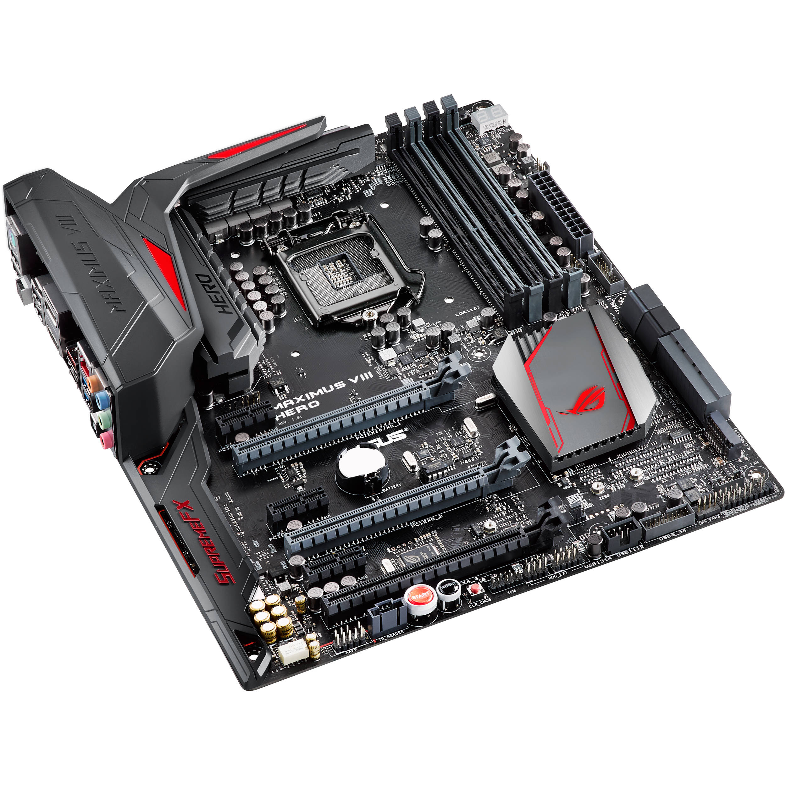 | The motherboard is the foundation of a computer in which it allocates power and allows communication to the CPU, RAM and all the other hardware components. | ATX Form Factor  30.5 cm x 24.4cm (12 inch x 9.6 inch) | Intel Core i7-6700K Skylake Quad Core 4.0GHz (4.2GHz Turbo) CPU
BIOS/UEFI |  | BIOS is a system which boots up the operating system on the computer.  UEFI is an interface which it connect the PC’s firmware to its operating system.

 | Image/ Reference | Function | Compatible Motherboard | Socket Type
CPU | Intel Core i7-6700K Skylake Quad Core 4.0GHz (4.2GHz Turbo) CPU  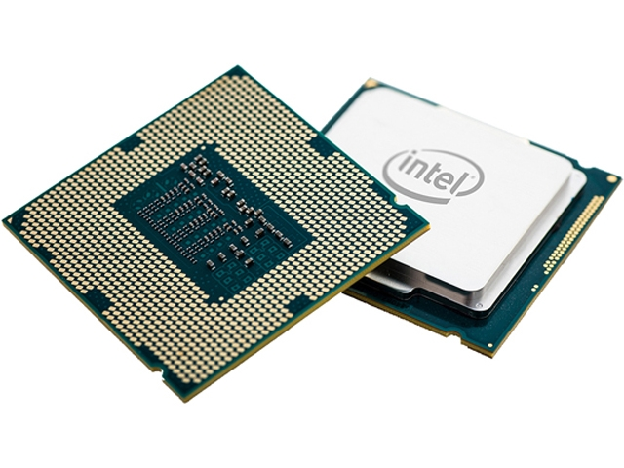 | The CPU carries out instructions of a computer system. I.e. input/output, logical operations, arithmetic operations, etc. | Asus Maximus VIII Hero Intel Z170 ATX Motherboard | FCLGA1151
Power supply | 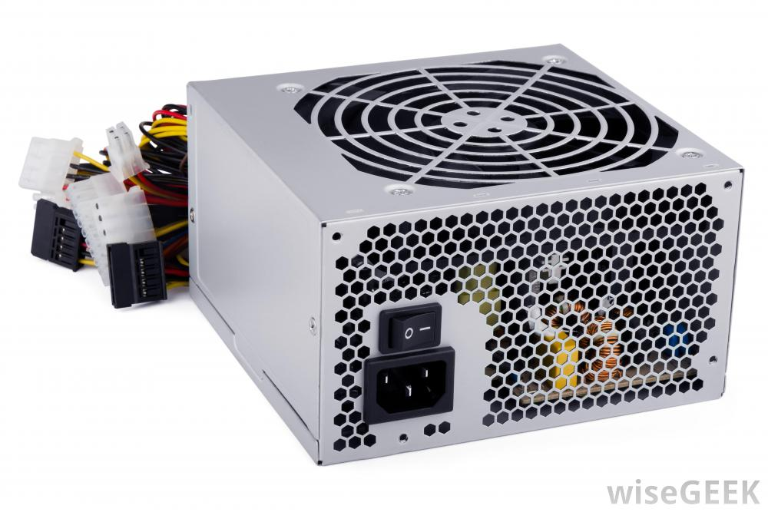 | The PCU converts AC power to low-voltage, regulated DC power for the components of the PC.
Fan and heat sink or cooling for CPU | 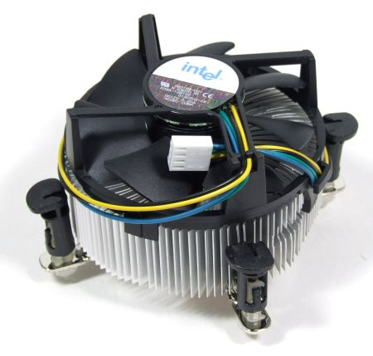 | The HSF help cool the CPU of the PC to prevent the CPU from overheating. Active heatsink is usually a fan type ; passive is an aluminium radiator. | Asus Maximus VIII Hero Intel Z170 ATX Motherboard

Ports | Image / Reference | Function | Number of Pins | Transfer Rate
Parallel | 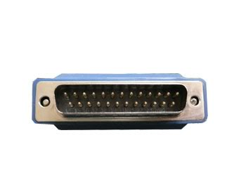 | The function of a parallel port is to connect computers, printers and other devices with demand for high bandwidth. | 25 pins | 150 Kbps
Serial | 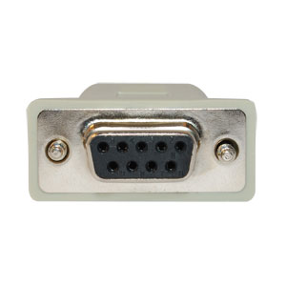 | A serial port sends data by one bit at a time. It was commonly used for a mouse and modems, but it can be used for networks and printers. | 9 pins | 9600 Bps
USB 2.0 | 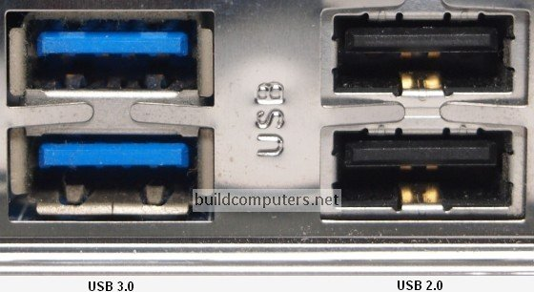 | A USB transmits, receives or controls information over the bus. It is possible to implement multiple functions into a USB and embed a hub with a single USB cable. | 4 pins | 480 mbps / 60 MBps
USB 3.0 |  |  | 4 pins | 5gbps / 640MBps
Thunderbolt | 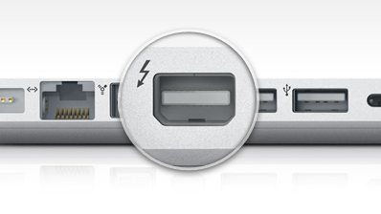 | Thunderbolt has many functions. For example, it can be used for: Video Capture & Playback, SCSI, super-fast graphics and other PCI express cards. | 20 pins | Thunderbolt 1: 10Gbps  Thunderbolt 2: 20Gbps

Memory | Image / Reference | Function | Number of Pins | Memory Speed (Hz) | Maximum Data Rate (Bps)
ROM |  | ROM is a permanent storage of memory which cannot be modified, unlike RAM.
SRAM (cache) |  | Static RAM is RAM that keeps bits in its memory as long as the power is on.
DDR3 SDRAM | 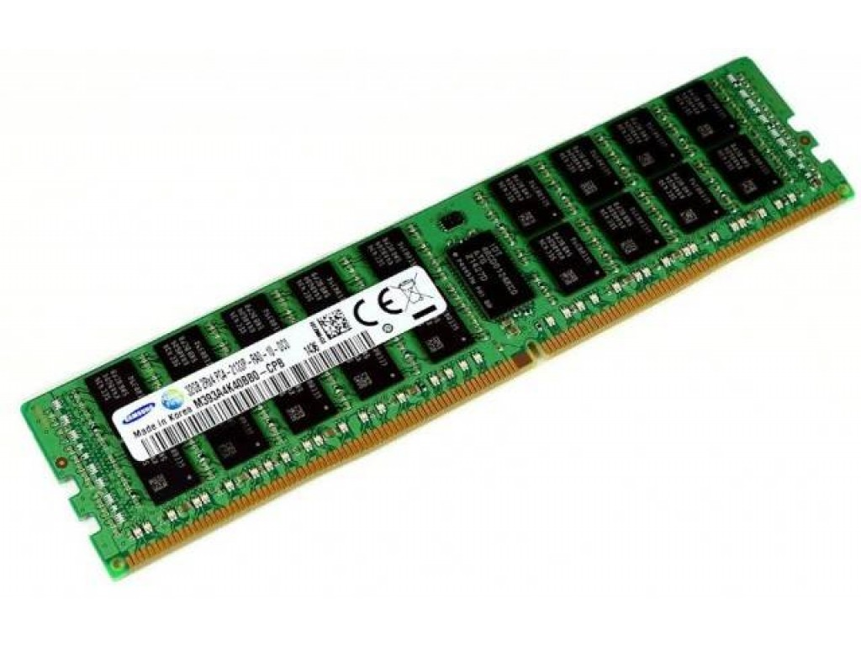 | Synchronous DRAM is a type of dynamic RAM that is synchronized with the clock speed of the microprocessor in which the RAM is optimized for. | 240 pins | 800 MHz | 2133 Mb/s
DDR4 SDRAM | 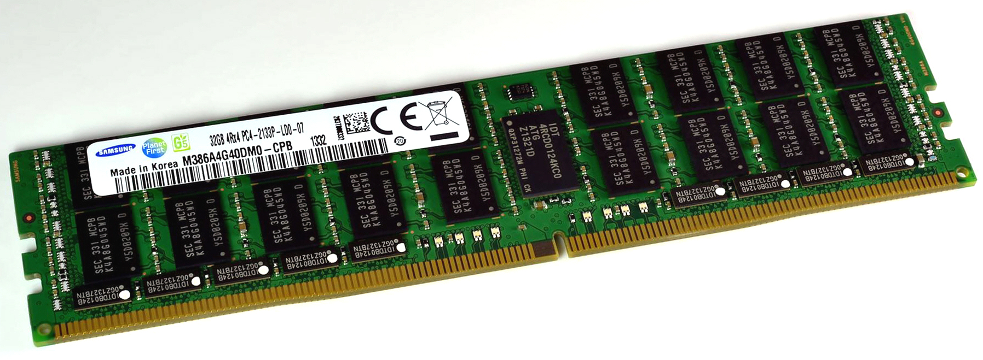 |  | 288 pins | 1600 Mhz | 3200 Mb/s

Expansion Slots | Image /Reference | Function | Transfer Rate
PCI | 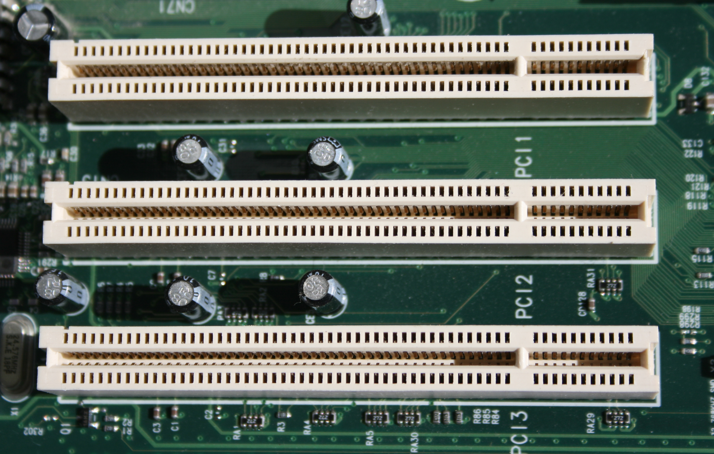 | The PCI transmits both address and data signals, sending the address on one clock cycle and data on the next. Burst data can be sent starting with an address on the first cycle and a sequence of data transmission on a certain number of successive cycles. | 533 MBs
PCIe | 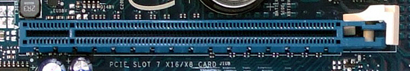 | PCIe transfers data over two signal pairs; two wires for transmitting and two wires for receiving. It has lanes which are capable of sending and receiving 8-bit data packets simultaneously between two points. | 500 MBs
AGP | 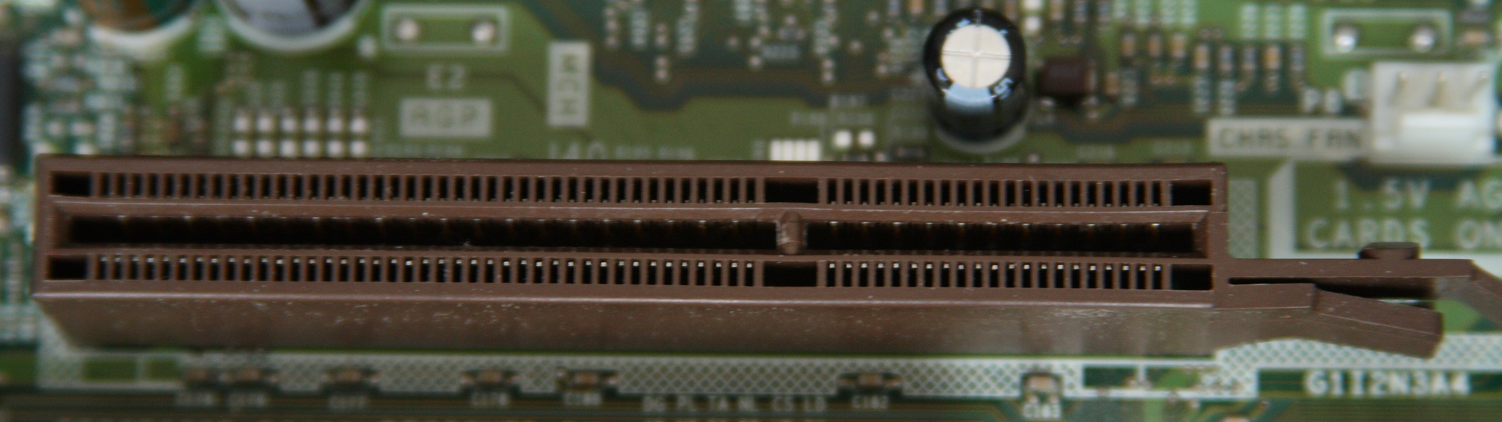 | The AGP is a high-speed port attaches the video card to a computer system. With the AGP you are able to play more complex programs with high demands. | 533 MBs

Interfaces | Image /Reference | Function | Transfer Rate | Number of Devices
PATA | 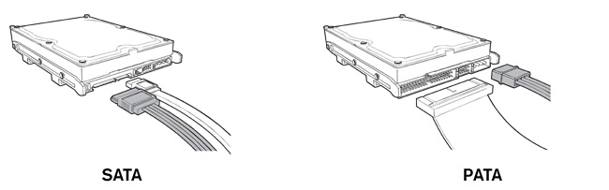 | PATA is a standard interface for the connection of storage devices, i.e. optical disk drives, hard disk drives, etc. | 133 MBs | 2
SATA |  | SATA is a bus interface that connect mass storage devices such as hard disk drives, optical drives and SSDs to a bus interface. | 600 MBs | 2
SCSI - 1 | 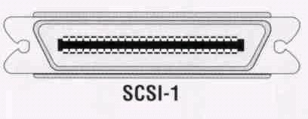 | SCSi is a parallel interface that is attacked to printers, disk drives, scanners and other peripherals. | 5 MBps | 7 devices + 1 adapter
Ultra320 SCSI | 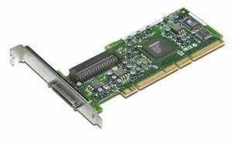 | Ultra320 SCSI has the same function as the SCSI-1 but with much faster speeds. | 320 MBps | 15 devices + 1 adapter

Input Devices | Image /Reference | Function | Connection type
Keyboard | 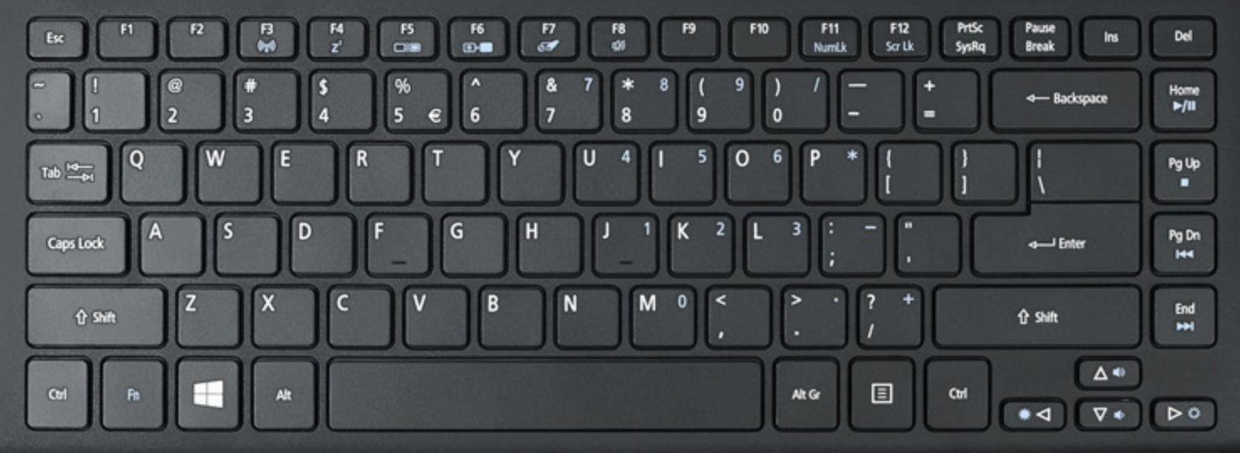 | The keyboard helps the user input data to the computer. | USB
Mouse | 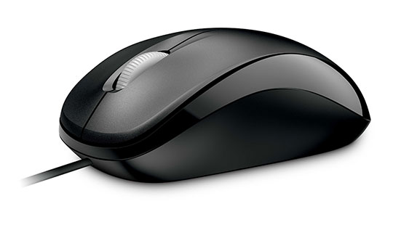 | The mouse helps the user navigate through the software. | USB
Scanner | 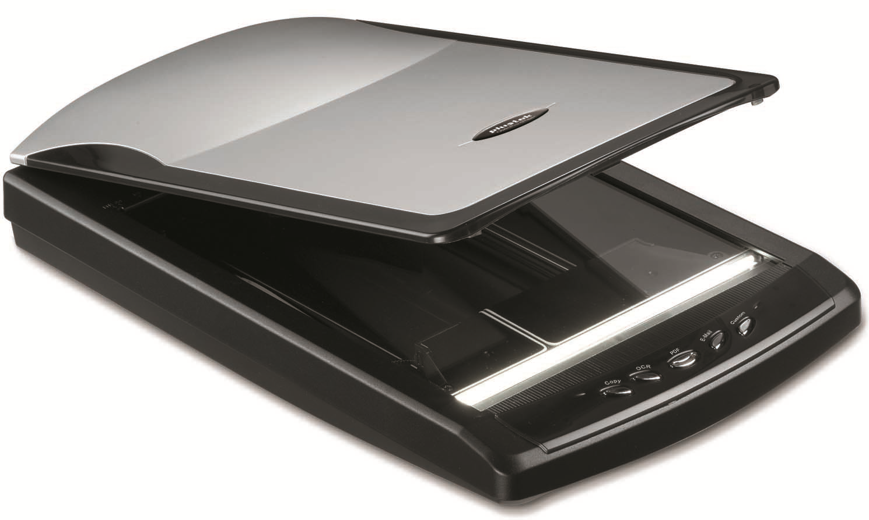 | The scanner captures images from a photographic display into a computer editing display. | USB
WebCam | 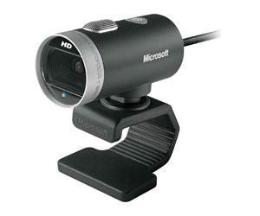 | The webcam is used to film the user, it’s uses vary from group calls to filming content to upload online as entertainment. | USB

Monitors | Image /Reference | Function | Screen Resolution | Screen Size | Connection Type
CRT | 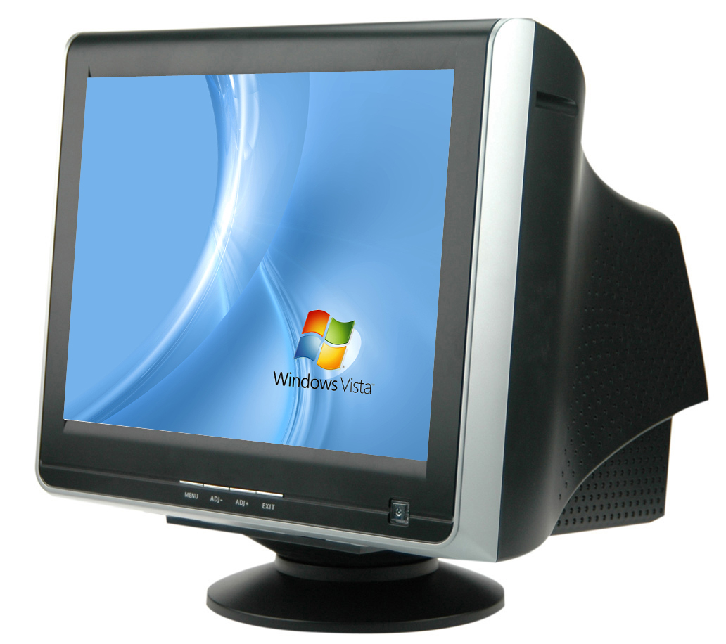 | The CRT monitor has a vacuum tube that contains electron guns and a phosphorescent screen which displays images. | 640x480 pixels | 19 inch | VGA
Flat Screen e.g. LCD | 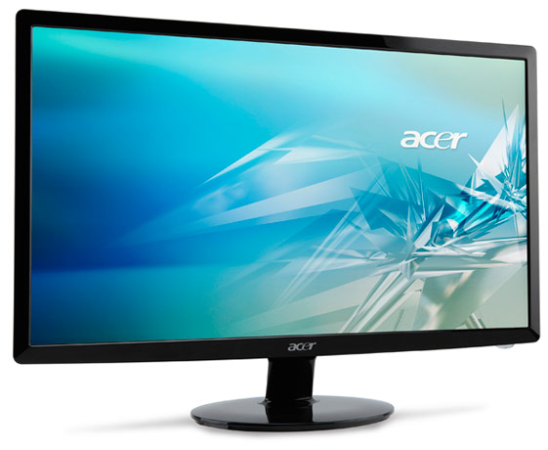 | The LCD monitor uses the light-modulating properties of liquid crystals to emit light (not directly) through the pixels. | 1920 x 1200 | 24 inch | HDMI / DVI

Printers | Image /Reference | Function | Pages/Minute | Connection Type
InkJet | 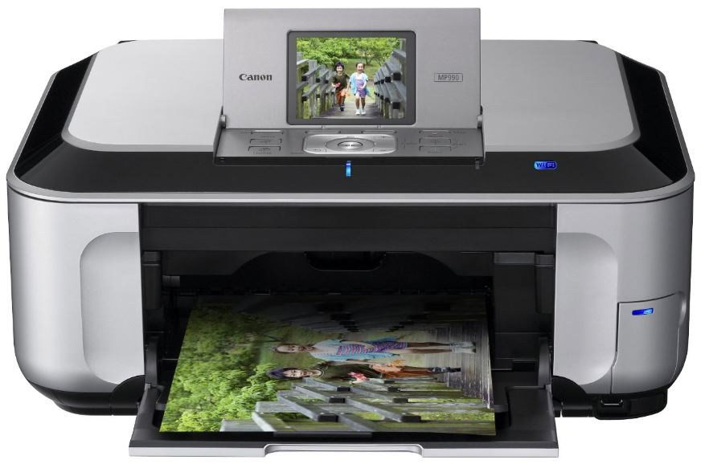 | The inkjet printer creates a digital image by propelling droplets of ink on to paper, plastic, etc. Inkjet is the most common printer used. | InkJet printers can print up to 6 to 20 pages per minute. | USB
All-in-One | 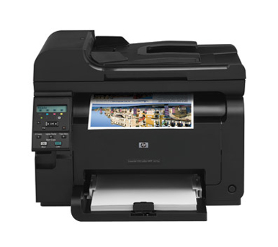 | The AiO printer operates the functionality of multiple devices in one. The AiO printer can have based on an inkjet printer or a laser printer. | All-in-One printers can print up from 12 to 45 pages per minute. | USB / Ethernet / Wi-Fi

Backing Storage | Image /Reference | Function | Fixed or Portable | Typical data transfer rate | Typical Capacity
Magnetic Disk | 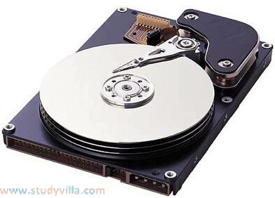 | The HDD is used for storing and retrieving digital information using rigid, rapidly rotating disks. | Fixed | 30 MBps | 2 TB
Solid State Drive | 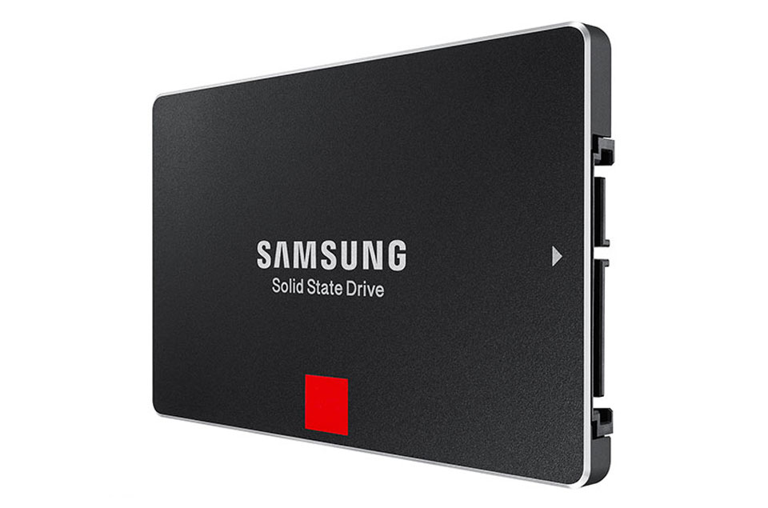 | The SSD has the same function as a HDD but, unlike HDDs, SSDs don’t have any moving parts. | Fixed | 1500 MBps | 250 GB
Pen drives | 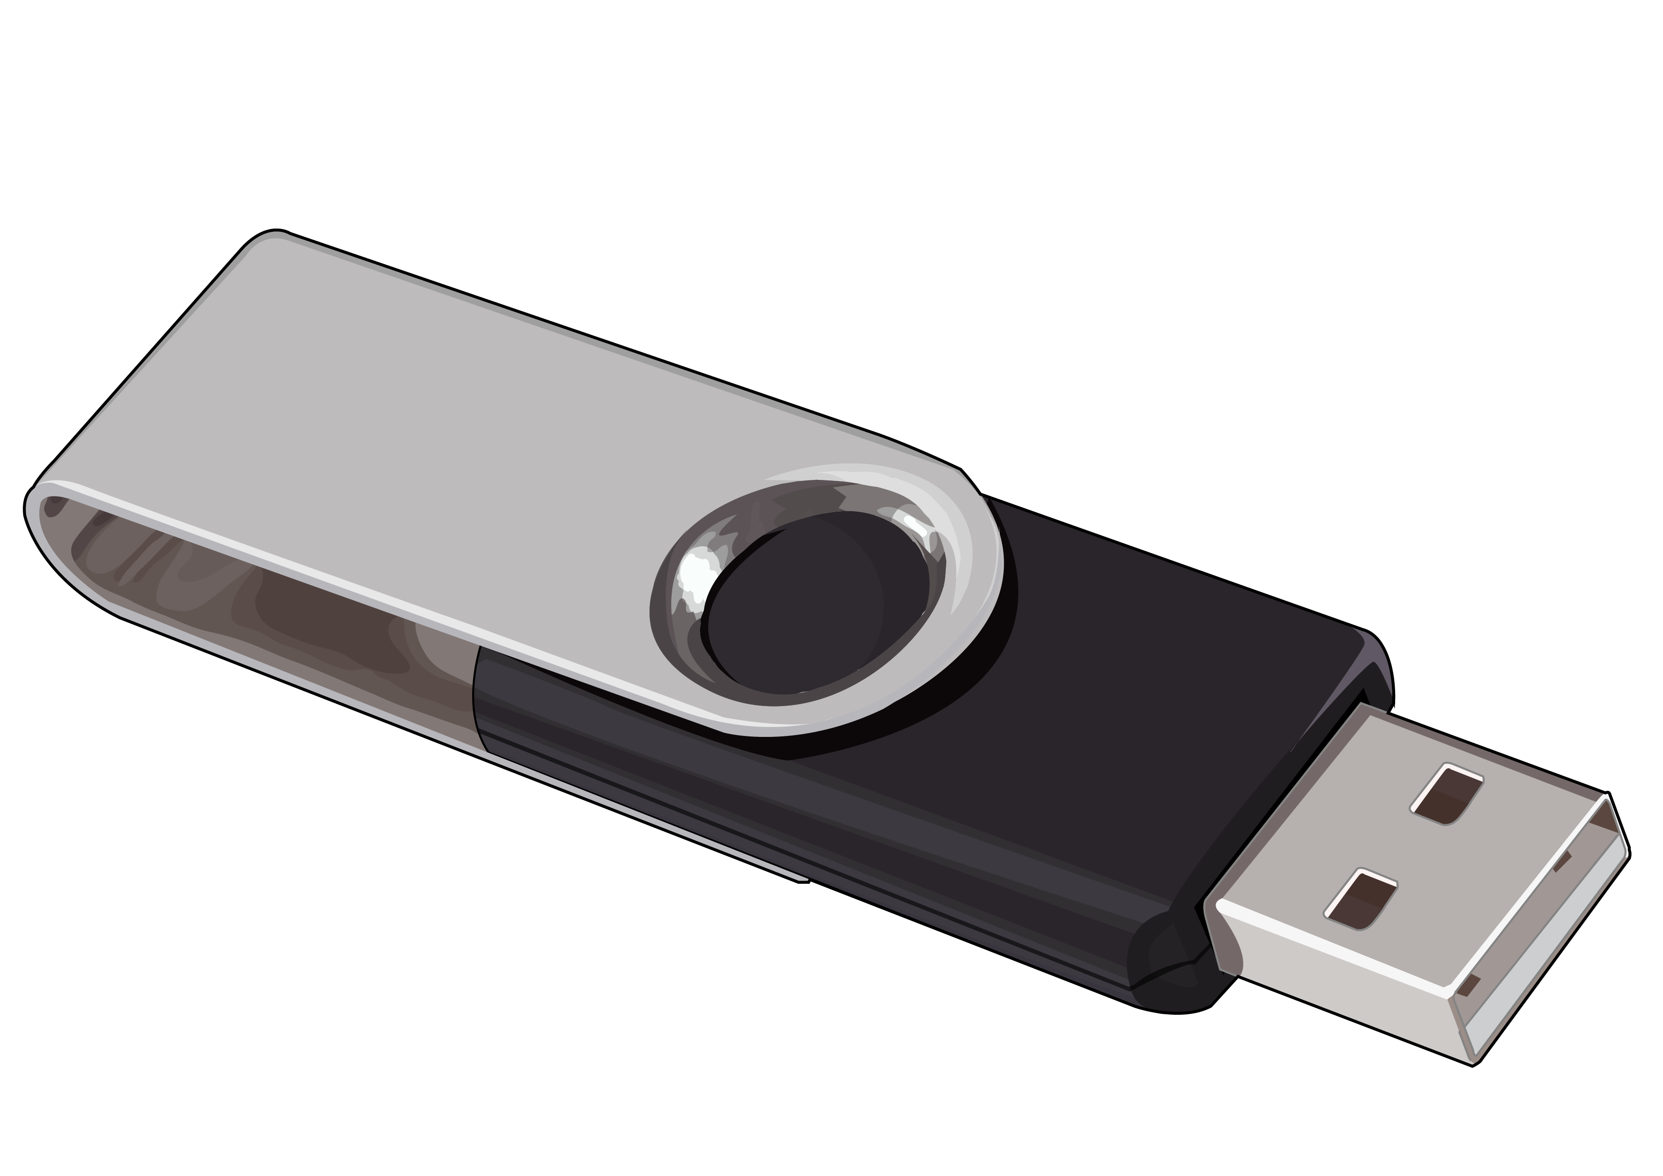 | Pen drives can be used for storage, data back-up and transfer of computer files. | Portable | 120 MBs | 64 GB
Flash memory cards /  SD Card | 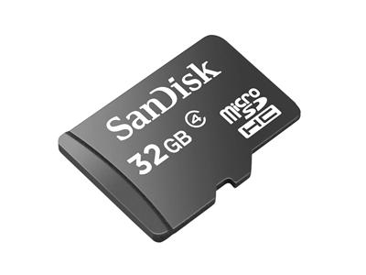 | Memory cards stores data such as text, pictures, audio and video. | Portable | 30 MBs | 32 GB
Optical Media
CD | 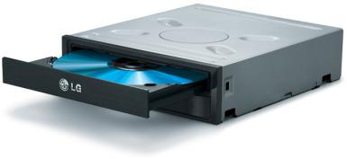 | Discs are capable of storing large amounts of data on one disc the size of a compact disk. | Disc: Portable  ROM: Fixed | 1.2 MBs | 700 MB
DVD | 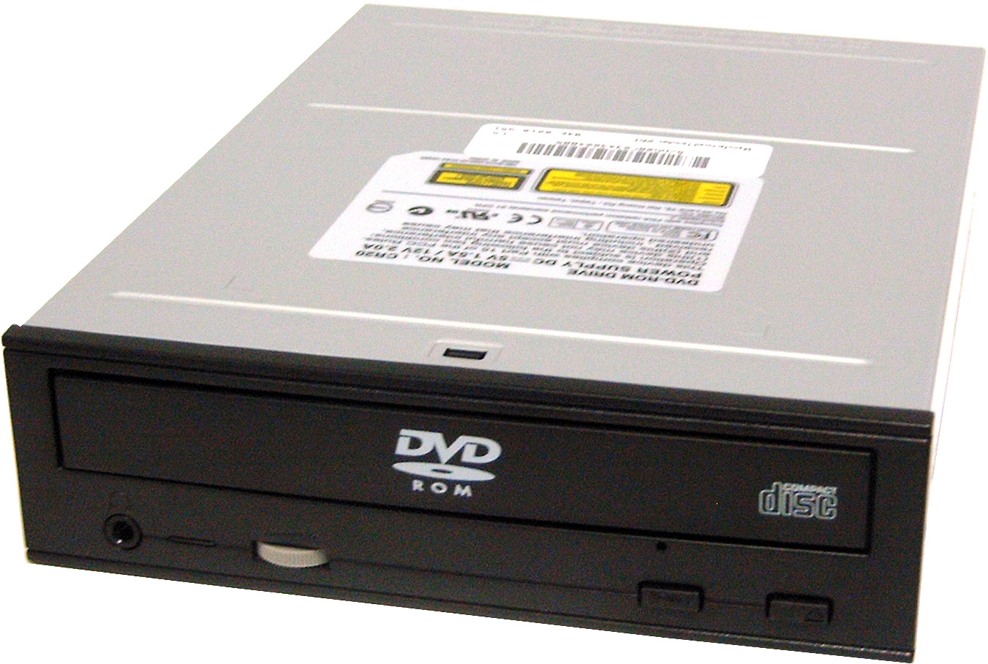 |  | Disc: Portable  ROM: Fixed | 1.321 MBs | 4.7 GB
Blu-Ray | 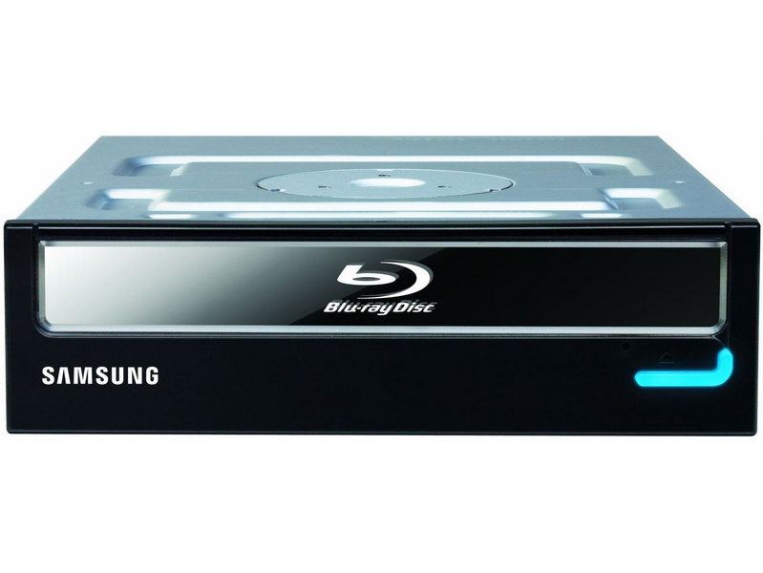 |  | Disc:  Portable  ROM: Fixed | 54Mbps | 50 GB

Cabling | Image /Reference | Function | Image of connector | Pins/Conductors
EIDE (PATA) Data Cable | 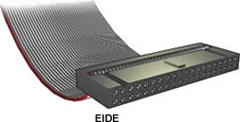 | It connects devices together like the hard driver and the motherboard to share data via parallel connection. | 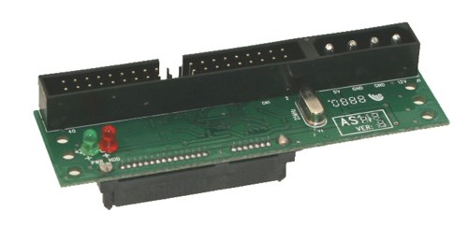 | 40
EIDE Power Cable and connector (Molex) | 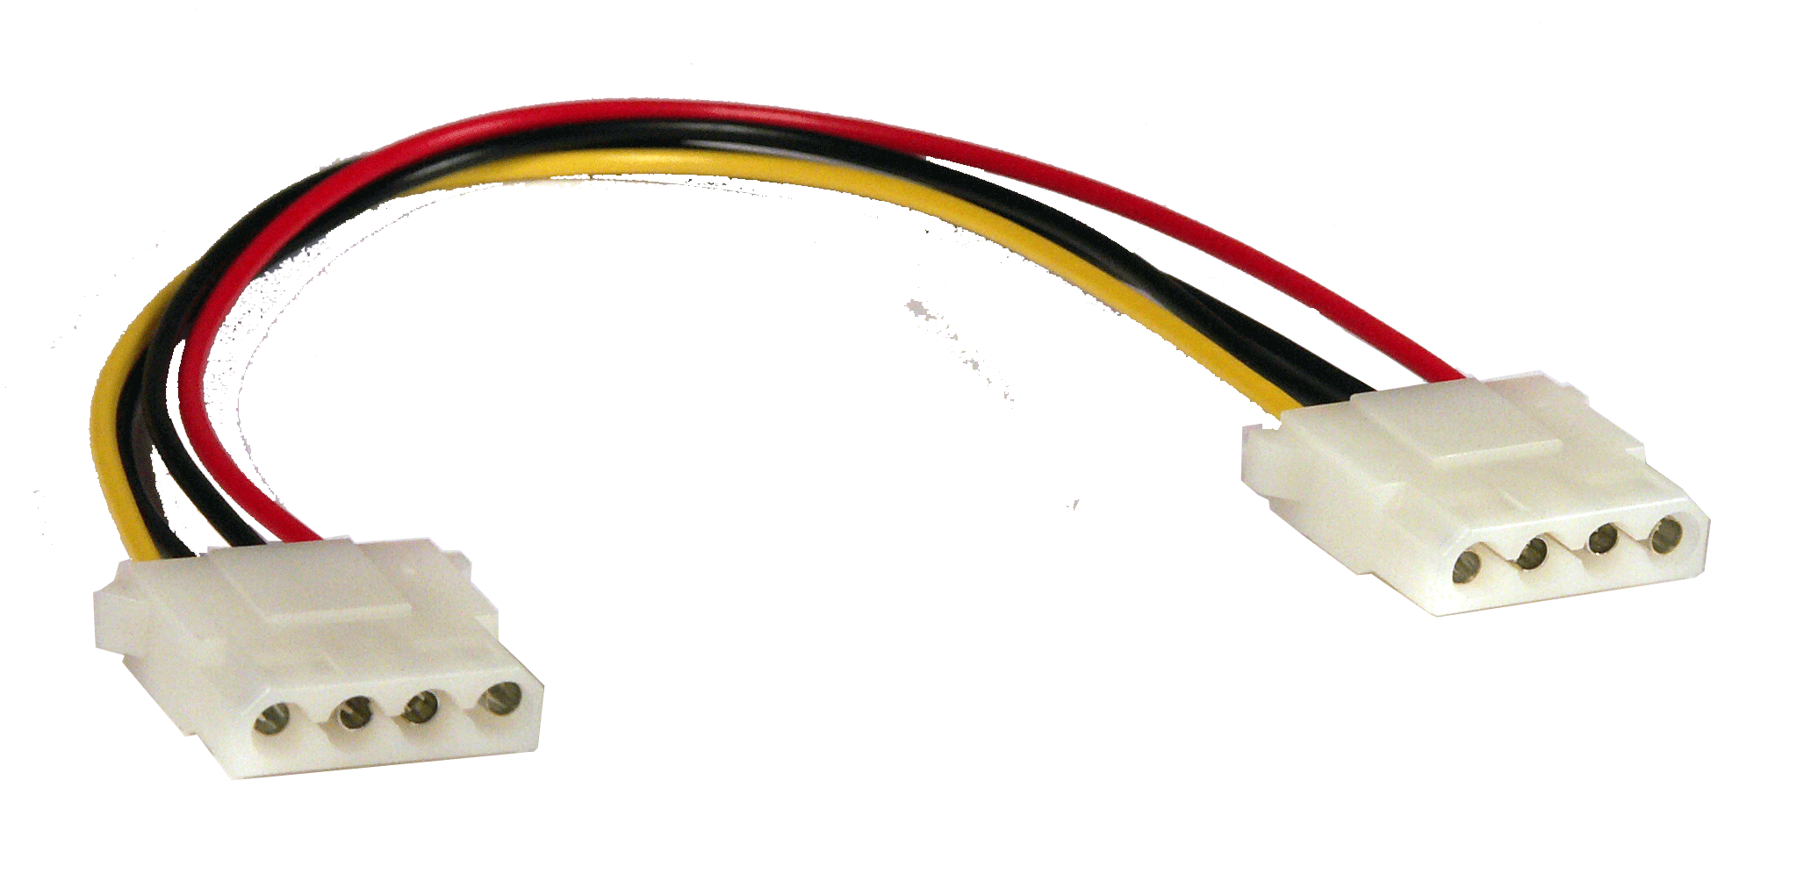 | The function of this cable is to power the PATA hard drive. | 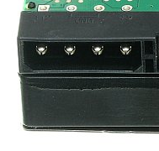 | 4
SATA data cable | 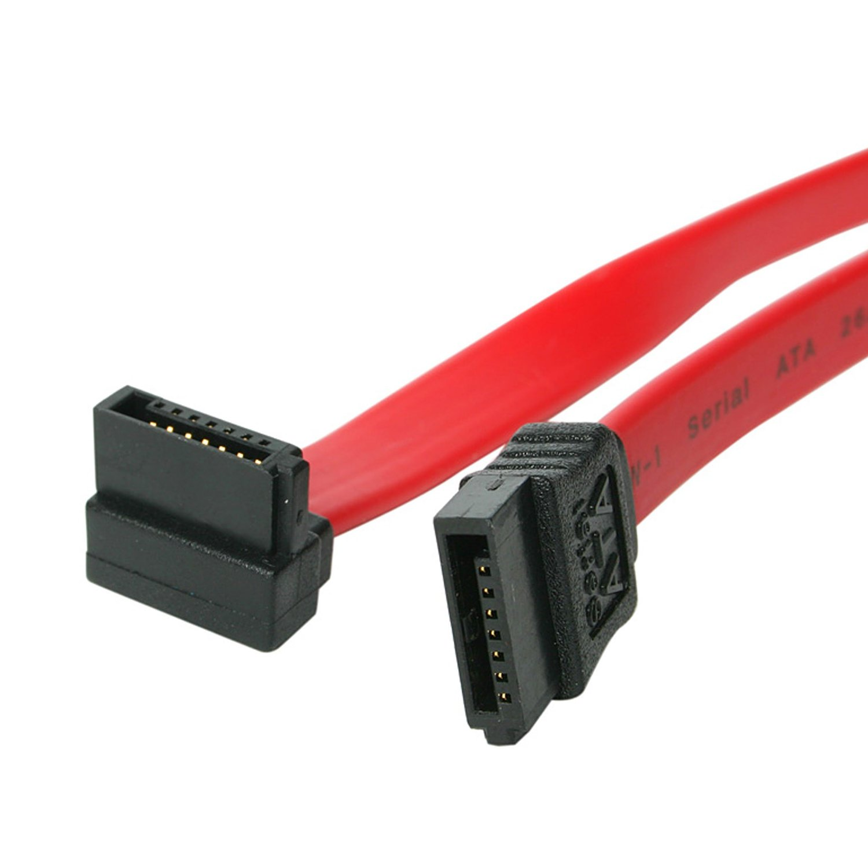 | Serial ATA connects the host bus adapters to mass storage devices such as HDD, optical drives and SSDs. | 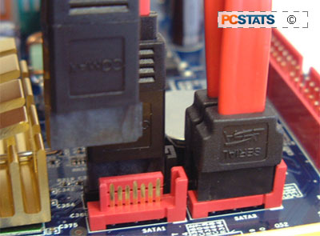 | 7
SATA power cable | 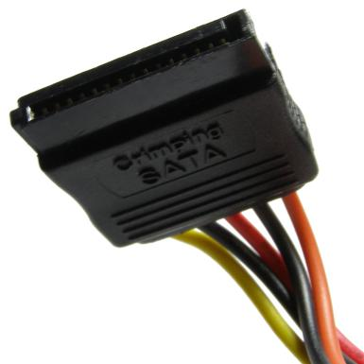 | The function of this cable is to power the SATA hard drive. | 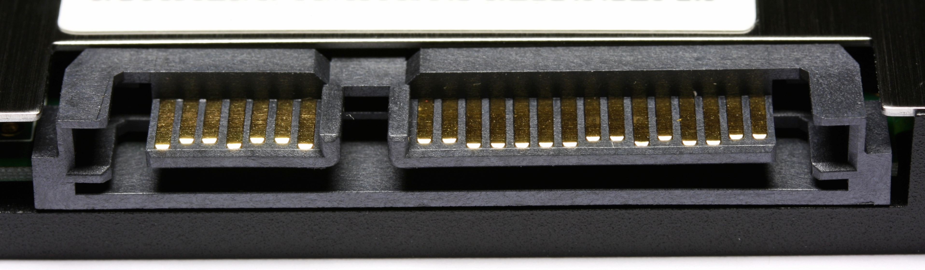 | 15
Network Cables
Co-axial | 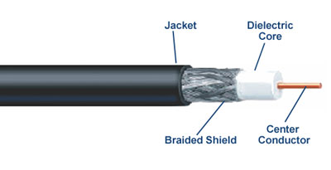 | Coaxial cable can be used for Ethernet and other types of local area network. | 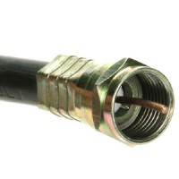 | 1
Optical | 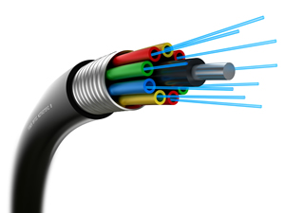 | Optical fibre cables are used to transfer signals using light through thin, flexible glass fibres. This method of data transmission is extremely fast because light is the fastest traveling thing in the known universe. | 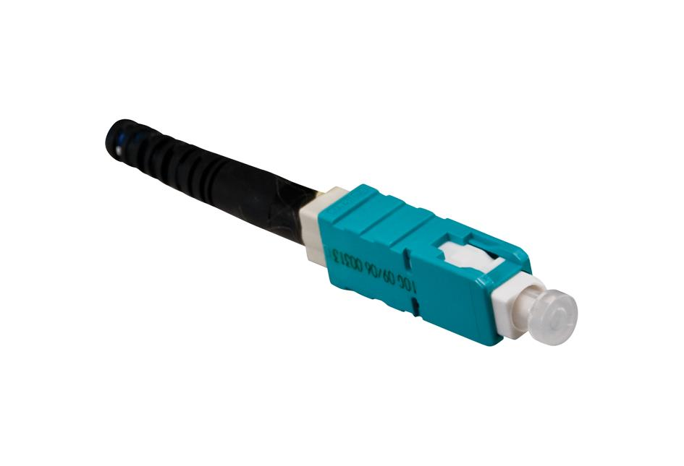 | 1
Twisted Pair | 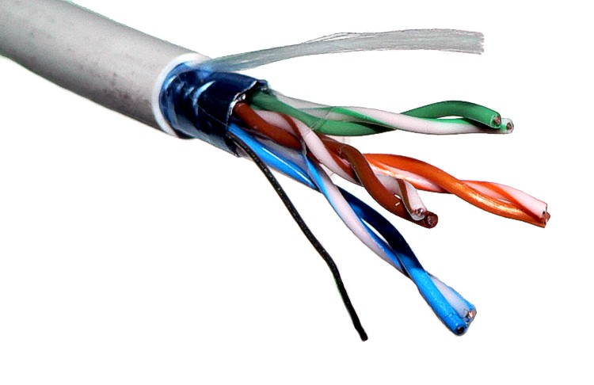 | STP cables are used in older telephone networks, as well as network and data communications. | 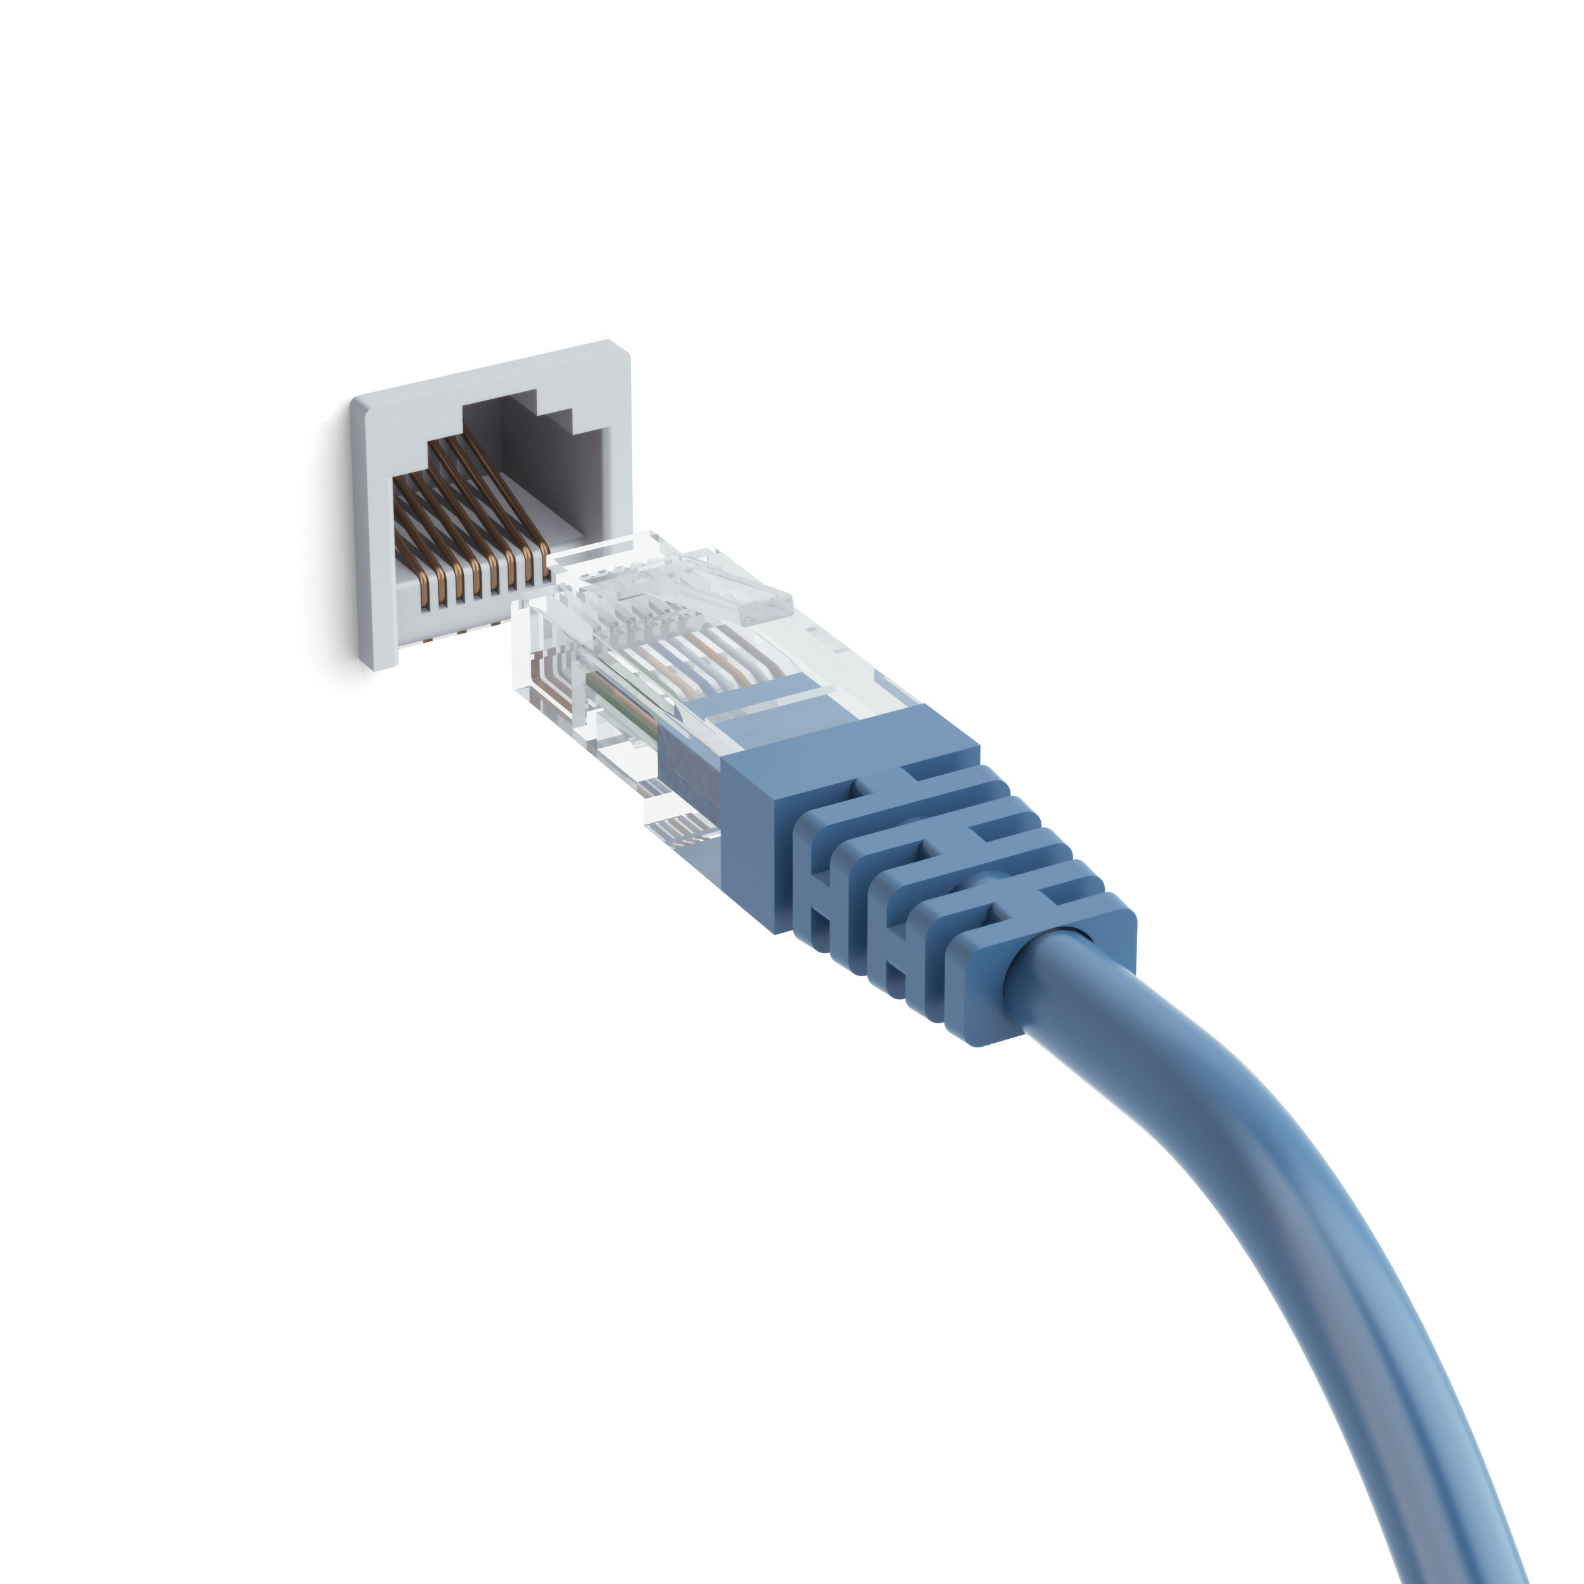 | 8

Criteria

To achieve the criteria, you must show that you are able to:

Unit | No | Criteria | Evidence | Student Tracking
2 | 1 | explain the function of computer hardware components | Complete the following tables:  Motherboard  CPU  Ports  Memory  Expansion Slots  Interfaces  Input Devices  Monitors  Printers  Backing Storage  Optical Media  Cabling

